ultramirinc.champs_mood

Class MyViewHolderSchedule

java.lang.Object

android.support.v7.widget.RecyclerView.ViewHolder ultramirinc.champs_mood.MyViewHolderSchedule



public class MyViewHolderSchedule

extends android.support.v7.widget.RecyclerView.ViewHolder

Created by William on 2017­04­13. Transforms raw Data into a visual interpretation for the user.

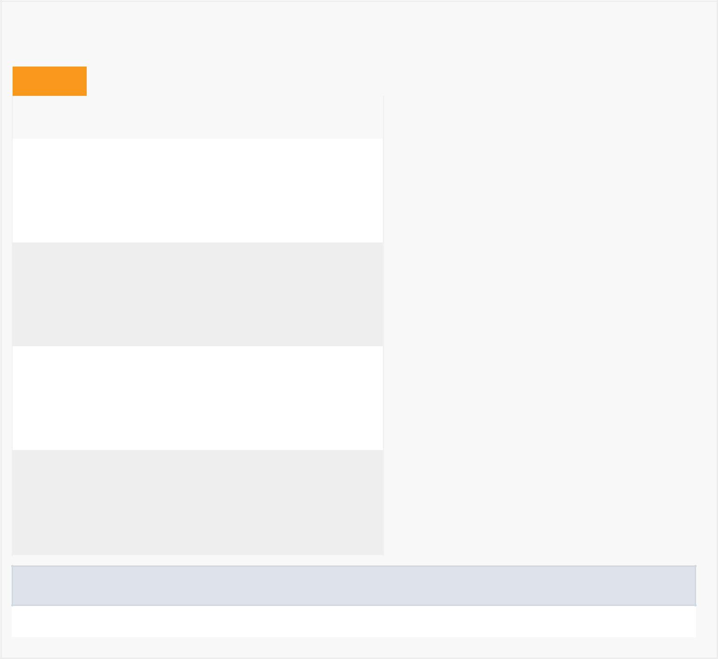

*Field Summary*

Fields

|  |  |
| --- | --- |
| Modifier and Type | Field and |
|  | Description |

private android.widget.TextView dayView

Contains the TextView of the break's day

private android.widget.Button delete

Contains the Button of the break's delete button

private android.widget.TextView fromTimeView

Contains the TextView of the break's begin time

private android.widget.TextView toTimeView

Contains the TextView of the break's end time

Fields inherited from class android.support.v7.widget.RecyclerView.ViewHolder

itemView



*Constructor Summary*

Constructors

Constructor and Description

MyViewHolderSchedule(android.view.View itemView)



|  |  |  |  |  |  |  |  |  |  |
| --- | --- | --- | --- | --- | --- | --- | --- | --- | --- |
| *Method Summary* | | | | |  |  |  |  |  |
|  |  | |  |  | |  |  |  |  |
|  | All Methods |  |  | [Instance Methods](javascript:show(2);) | |  |  | [Concrete Methods](javascript:show(8);) |  |
|  | Modifier and Type | | |  | Method and Description | | | | |
|  | void | | |  | bind(Break myBreak) | | | | |
|  |  |  |  |  | Binds the break's day, begin time and end time to their | | | | |
|  |  |  |  |  | respective TextView variables. | | | | |
|  |  |  |  | |  |  |  |  |  |
|  | android.widget.TextView | | | | getDayView() | | |  |  |
|  |  |  |  |  | Getter for dayView. | | | | |
|  | android.widget.Button | | | | getDelete() | | |  |  |
|  |  |  |  |  | Getter for delete. | | | | |
|  |  |  |  | |  |  |  | |  |
|  | android.widget.TextView | | | | getFromTimeView() | | | | |
|  |  |  |  |  | Getter for fromTimeView. | | | | |
|  | android.widget.TextView | | | | getToTimeView() | | | | |
|  |  |  |  |  | Getter for toTimeView. | | | | |
|  |  |  |  |  |  |  |  | |  |
|  | void | | |  | setDayView(android.widget.TextView dayView) | | | | |
|  |  |  |  |  | Setter for dayView. | | | | |
|  | void | | |  | setDelete(android.widget.Button delete) | | | | |
|  |  |  |  |  | Setter for delete. | | | | |
|  |  |  |  |  |  |  |  | |  |
|  | void | | |  | setFromTimeView(android.widget.TextView fromTimeView) | | | | |
|  |  |  |  |  | Setter for fromTimeView. | | | | |
|  | void | | |  | setToTimeView(android.widget.TextView toTimeView) | | | | |
|  |  |  |  |  | Setter for toTimeView. | | | | |
|  |  |  |  |  |  |  |  |  |  |

Methods inherited from class android.support.v7.widget.RecyclerView.ViewHolder

getAdapterPosition, getItemId, getItemViewType, getLayoutPosition, getOldPosition, getPosition, isRecyclable, setIsRecyclable, toString

Methods inherited from class java.lang.Object

clone, equals, finalize, getClass, hashCode, notify, notifyAll, wait, wait, wait



*Field Detail*

delete

private android.widget.Button delete

Contains the Button of the break's delete button

dayView

private android.widget.TextView dayView

Contains the TextView of the break's day

fromTimeView

private android.widget.TextView fromTimeView

Contains the TextView of the break's begin time

toTimeView

private android.widget.TextView toTimeView

Contains the TextView of the break's end time

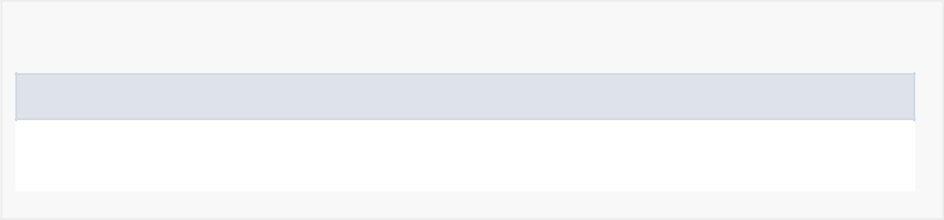

*Constructor Detail*

MyViewHolderSchedule

public MyViewHolderSchedule(android.view.View itemView)



*Method Detail*

bind

public void bind(Break myBreak)

Binds the break's day, begin time and end time to their respective TextView variables.

getDelete

public android.widget.Button getDelete()

Getter for delete.

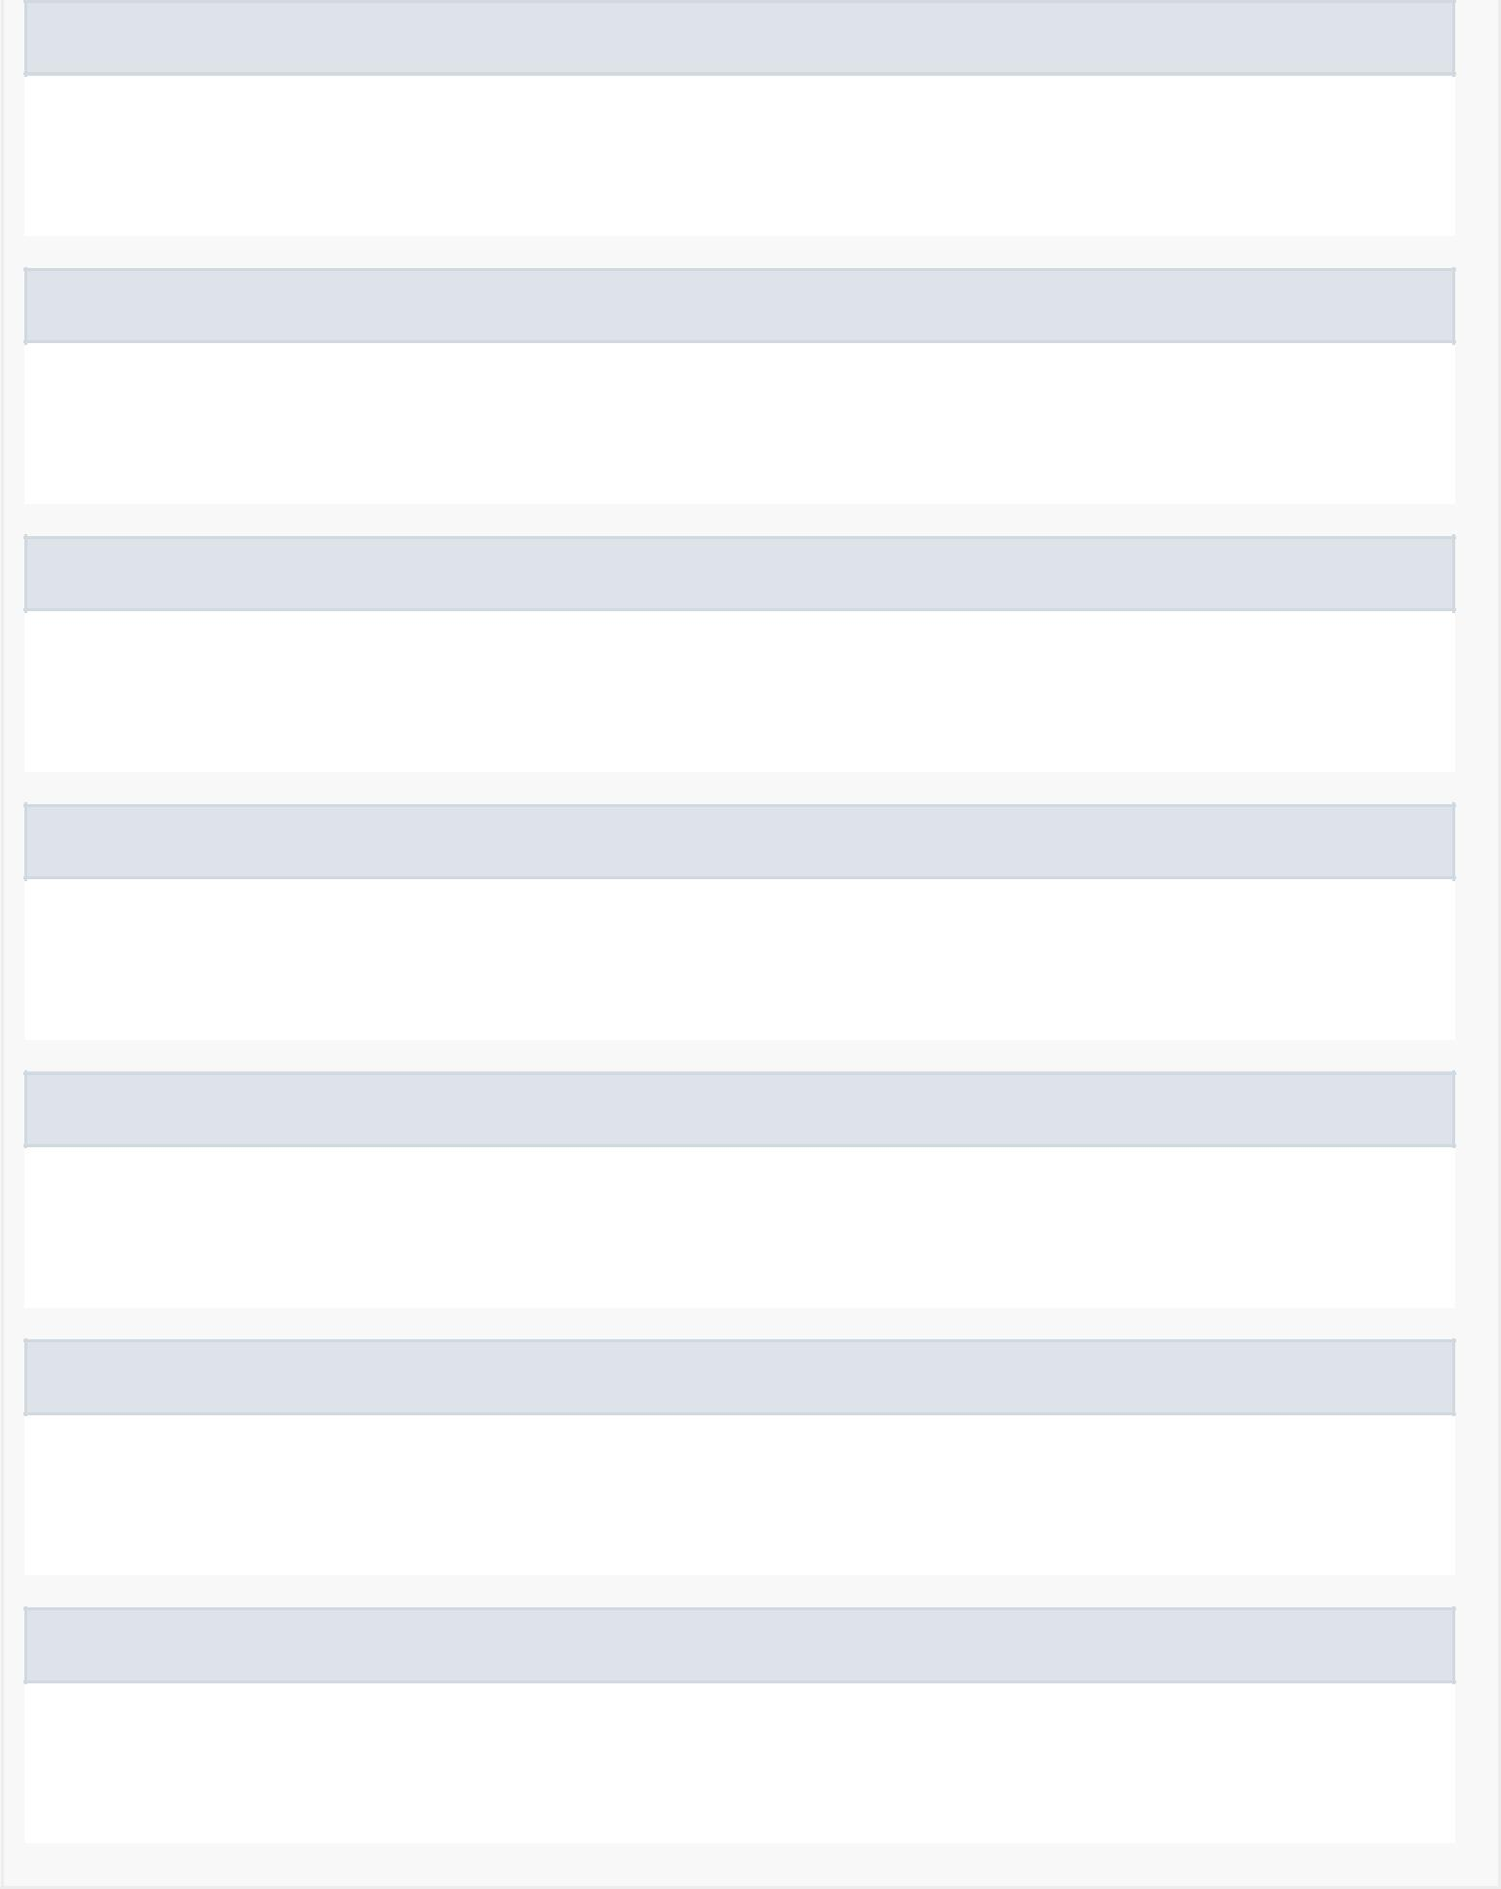setDelete

public void setDelete(android.widget.Button delete)

Setter for delete.

getDayView

public android.widget.TextView getDayView()

Getter for dayView.

setDayView

public void setDayView(android.widget.TextView dayView)

Setter for dayView.

getFromTimeView

public android.widget.TextView getFromTimeView()

Getter for fromTimeView.

setFromTimeView

public void setFromTimeView(android.widget.TextView fromTimeView)

Setter for fromTimeView.

getToTimeView

public android.widget.TextView getToTimeView()

Getter for toTimeView.

setToTimeView

public void setToTimeView(android.widget.TextView toTimeView)

Setter for toTimeView.